11.6 Making salts (PartⅢ)
Name: ____________________ Class: ____________________ Due date: 12.5
1. Which substance reacts with dilute sulfuric acid to form a salt that can be removed from the resulting mixture by filtration? （ ）
A aqueous barium chloride
B aqueous sodium hydroxide
C copper
D copper(II) carbonate
2. An excess of aqueous sodium sulfate was added to aqueous barium chloride and the mixture was filtered.
Which row shows the identity of the residue and the substances present in the filtrate? （ ）
 | residue | substances in filtrate
A | barium sulfate | barium chloride and sodium chloride
B | barium sulfate | sodium chloride and sodium sulfate
C | sodium chloride | barium chloride and sodium sulfate
D | sodium chloride | barium sulfate and sodium sulfate

3. Lead(II) sulfate is an insoluble salt.
Which method is suitable for obtaining solid lead(II) sulfate? （ ）
A Mix aqueous lead(II) nitrate and aqueous potassium sulfate, heat to evaporate all of the water, collect the solid and then wash and dry it.
B Mix aqueous lead(II) nitrate and aqueous potassium sulfate, filter, collect the filtrate, crystallise, then wash and dry the crystals.
C Mix aqueous lead(II) nitrate and dilute sulfuric acid, filter, then wash and dry the residue.
D Titrate aqueous lead(II) hydroxide with dilute sulfuric acid, crystallise, then wash and dry the crystals.

4. Silver(I) chromate(VI) is an insoluble salt. It is prepared by precipitation. $20cm^{3}$ of aqueous silver(I) nitrate, concentration $0.2mol/{dm}^{3}$ was mixed with $20cm^{3}$ of aqueous potassium chromate(VI), concentration $0.1mol/{dm}^{3}$ After stirring, the mixture was filtered. The precipitate was washed several times with distilled water. The precipitate was then left in a warm oven for several hours.
$$2{AgNO}_{3}(aq)+K_{2}{CrO}_{4}(aq)→{Ag}_{2}{CrO}_{4}(s)+2{KNO}_{3}(aq)$$
These questions refer to the preparation of the salt.
Why is it necessary to filter the mixture after mixing and stirring?
..................................................................................................................................
..................................................................................................................................
What is the purpose of washing the precipitate?
..................................................................................................................................
Why leave the precipitate in a warm oven?
..................................................................................................................................
..................................................................................................................................
5.
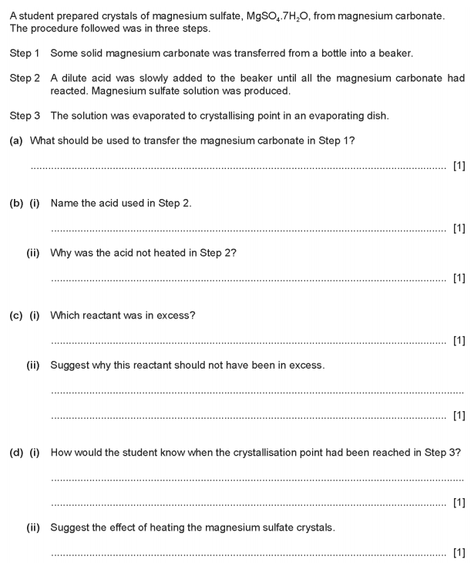

6.
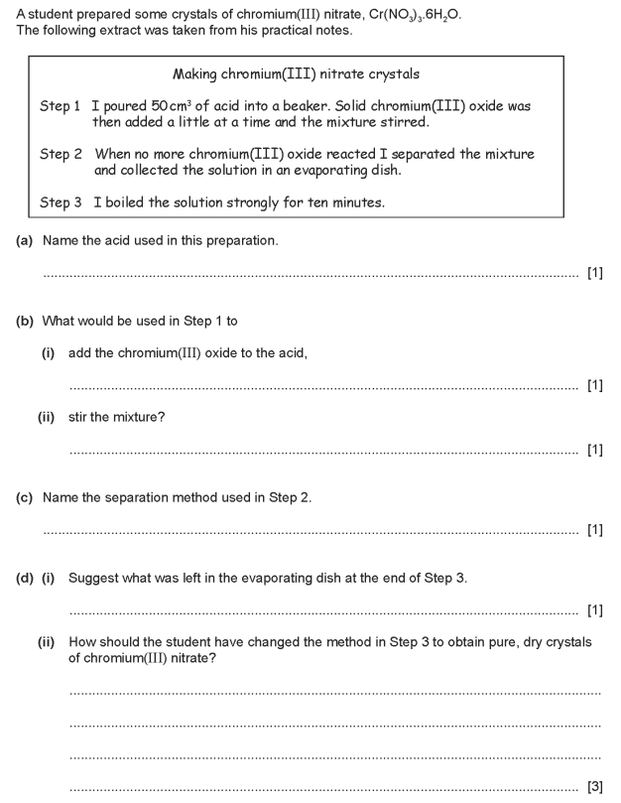

7.
